**Assignment 6**

1. Exercise (Flow builder)

As System administrator I want to post Opportunity details (with Opportunity link) to the related

Account’s feed, whenever an Opportunity gets created with an amount greater than $100k. Create

point and click automation for this.

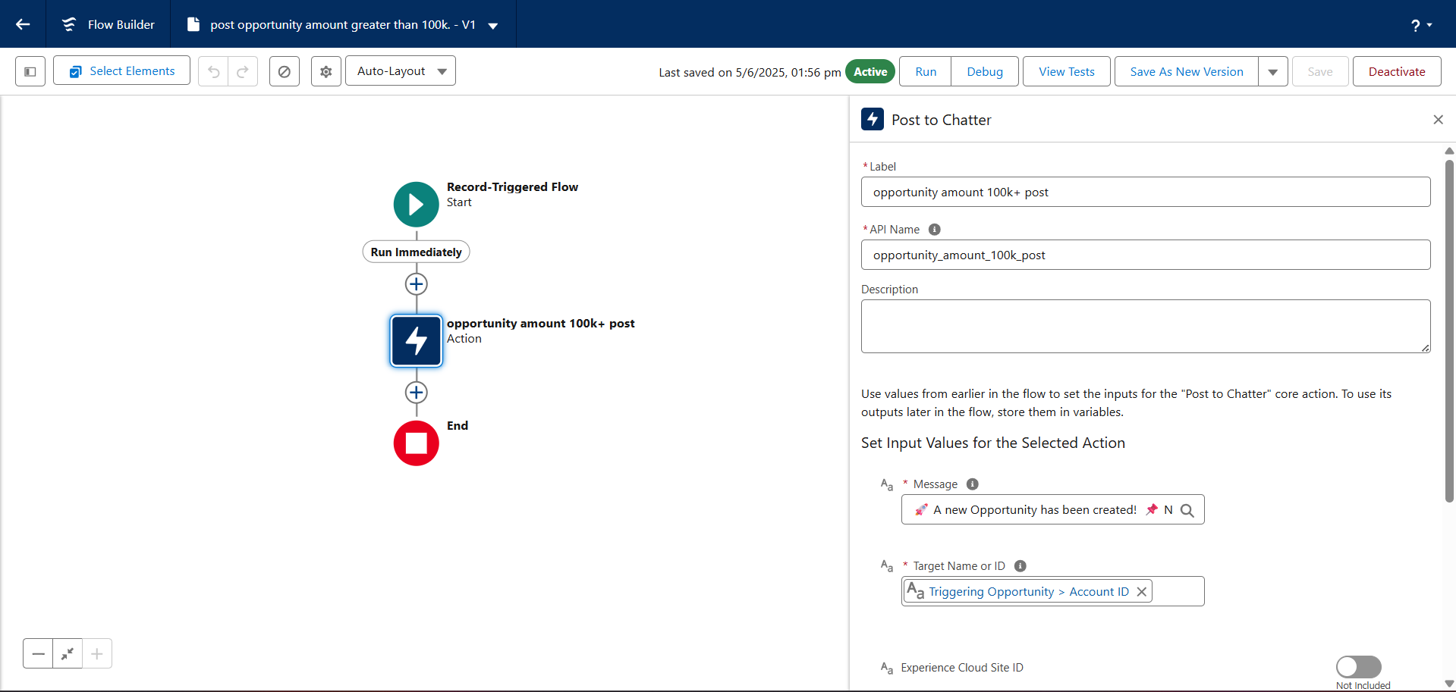

1. Create 2 Objects If not already exists:

Loan (Amount,Name,Address,City (Lookup to CityManager)........)

Create one master object CityManager(City,Manager(LookUp of User)) (Do some dummy entries for Testing:- Jaipur (Rahul, Ajmer Dipak)

Create an Approval Process on Loan,

If Amount greater than 15000

When submitted for approval then till approval/reject user cannot edit the record (System admin can edit).

Record must be approved/reject by Related Manager (CityManager-> Manager)

Mail should be sent to Owner on Approving and Rejecting of the Loan

1. After Approving/Rejecting ,record should be editable

